DATA WAREHOUSING AND DATA MINING
Activities 1 to 4: Answers
Name: Kamesh S
Reg. No.: 192521358
SIMATS Engineering, Chennai
Activity 1: Design a Star Schema (15 Marks)
Question 1: Design a star schema to analyze student academic performance across departments, courses and semesters. Identify the fact and dimension tables, their attributes, and the primary and foreign keys. Draw the star schema diagram.
Step 1: Business process, grain and measures
- Business process: student academic performance (examination results).
- Grain (one fact row): the result of ONE student in ONE course in ONE semester.
- Measures (numeric facts): marks obtained, maximum marks, grade point, attendance percentage, credits earned.
- Dimensions (points of view for analysis): Student, Course, Department, Semester (time).
Step 2: Fact table: FACT_STUDENT_PERFORMANCE
Attribute | Data type | Key | Description
Performance_ID | INT | PK | Surrogate key; unique id of each result row
Student_Key | INT | FK | References DIM_STUDENT
Course_Key | INT | FK | References DIM_COURSE
Department_Key | INT | FK | References DIM_DEPARTMENT
Semester_Key | INT | FK | References DIM_SEMESTER
Marks_Obtained | DECIMAL(5,2) | Measure | Marks scored by the student
Max_Marks | DECIMAL(5,2) | Measure | Maximum marks of the course
Grade_Point | DECIMAL(3,1) | Measure | Grade point earned (0 to 10)
Attendance_Pct | DECIMAL(5,2) | Measure | Attendance percentage in the course
Credits_Earned | INT | Measure | Credits gained (0 if failed)
Result_Status | VARCHAR(10) | Measure | Pass / Fail
Step 3: Dimension tables
DIM_STUDENT
Attribute | Key | Description
Student_Key | PK | Surrogate key
Roll_No |  | University roll / register number
Student_Name |  | Full name
Gender |  | Male / Female
Date_of_Birth |  | Date of birth
Admission_Year |  | Year of admission (batch)
City |  | Home city
DIM_COURSE
Attribute | Key | Description
Course_Key | PK | Surrogate key
Course_Code |  | e.g. CSA16
Course_Name |  | e.g. Data Warehousing and Data Mining
Credits |  | Credit value of the course
Course_Type |  | Theory / Lab / Elective
DIM_DEPARTMENT
Attribute | Key | Description
Department_Key | PK | Surrogate key
Department_Code |  | e.g. CSE, ECE, MECH
Department_Name |  | Full department name
HOD_Name |  | Head of the department
School_Name |  | School / faculty to which the department belongs
DIM_SEMESTER (time dimension)
Attribute | Key | Description
Semester_Key | PK | Surrogate key
Semester_No |  | 1 to 8
Semester_Type |  | Odd / Even
Academic_Year |  | e.g. 2023-2024
Start_Date |  | First day of the semester
End_Date |  | Last day of the semester
Step 4: Keys and relationships
Relationship | Primary key (dimension) | Foreign key (fact) | Cardinality
DIM_STUDENT to FACT | Student_Key | Student_Key | 1 : N
DIM_COURSE to FACT | Course_Key | Course_Key | 1 : N
DIM_DEPARTMENT to FACT | Department_Key | Department_Key | 1 : N
DIM_SEMESTER to FACT | Semester_Key | Semester_Key | 1 : N
The fact table primary key is Performance_ID. The four foreign keys together (Student_Key, Course_Key, Semester_Key and Department_Key) identify each result row and connect it to its dimensions.
Step 5: Star schema diagram
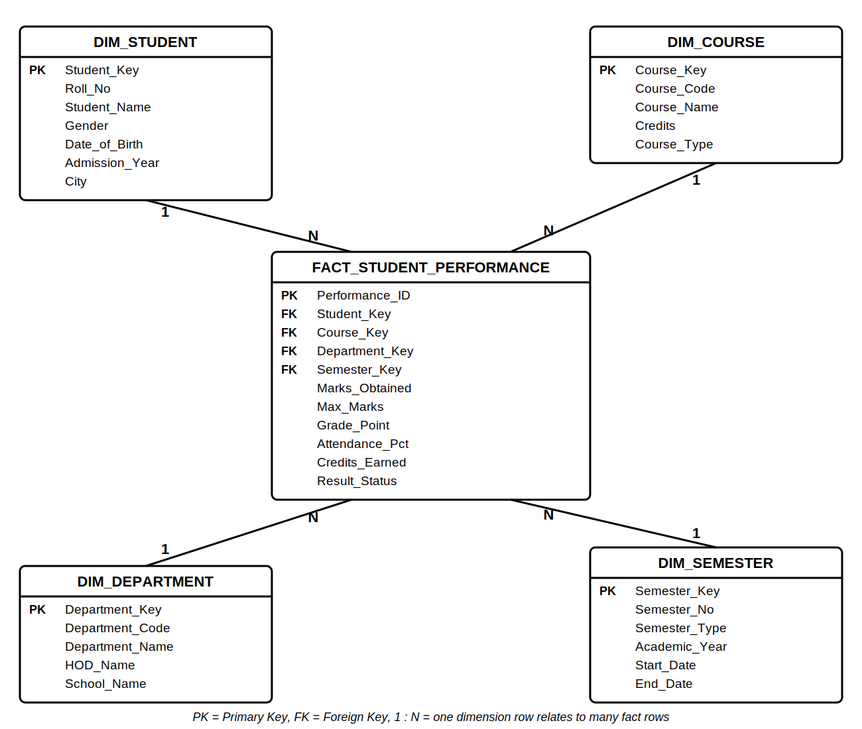
Figure 1: Star schema for student academic performance (fact table in the centre, four dimension tables around it).
Step 6: Analysis supported
- Average grade point of each department in each semester.
- Pass percentage of each course across semesters.
- Relationship between attendance and marks of students.
- Top-performing students per department and academic year.
Activity 2: Perform ETL Operations (10 Marks)
Question 2: Student data is collected from admission, examination and attendance systems and has missing values, duplicates, inconsistent department names and different date formats. Explain and demonstrate the ETL process, showing sample input, transformations and the final cleaned data loaded into the target table.
Overview of the ETL process
Admission, Examination and Attendance systems → EXTRACT → Staging area → TRANSFORM → LOAD → Data warehouse (target table)
Step 1: Extract (sample input records)
Data is read from the three source systems into a staging area. Each record is tagged with its source name and extraction time, and the sources are not changed.
Source 1: Admission system
Student_ID | Name | Department | Admission_Date
101 | Ravi Kumar | CSE | 15/06/2022
102 | priya sharma | Comp. Science | 2022-06-16
103 | ARUN RAJ | ECE | 17-Jun-2022
101 | Ravi Kumar | CSE | 15/06/2022
104 | Meena | Electronics & Comm | (missing)
105 | Karthik | Mech | 18/06/2022
Source 2: Examination system
Student_ID | Department | Exam_Date | Marks
101 | Computer Science & Engg | 2023-04-10 | 78
102 | CSE | 10/04/2023 | 85
103 | E.C.E | 10 Apr 2023 | 82
104 | ECE | 11/04/2023 | (missing)
105 | Mech | 12-Apr-2023 | 66
Source 3: Attendance system
Student_ID | Department | Attendance_%
101 | cse | 92
102 | Computer Science | 88
103 | ece | (missing)
104 | E & C | 76
105 | MECHANICAL | 81
Problems found: 1 duplicate record (Student 101 in admission); 3 missing values (admission date of 104, marks of 104, attendance of 103); the same department written in 4 or more ways; and 5 different date formats.
Step 2: Transform
No. | Problem | Transformation performed | Example (before → after)
1 | Duplicate records | Match on Student_ID, Name and Date; keep one copy | Student 101 (2 rows) → 1 row
2 | Inconsistent department names | Map every variant to one standard name using a lookup table | Comp. Science, cse, CSE → Computer Science and Engineering
3 | Different date formats | Parse each format (day first) and convert to ISO YYYY-MM-DD | 17-Jun-2022 → 2022-06-17; 10/04/2023 → 2023-04-10
4 | Missing attendance | Fill with the department mean of known values | Student 103 → 76.00
5 | Missing admission date | Replace with "Unknown" and flag the record | Student 104 → Unknown
6 | Missing exam marks | Not guessed (an exam result cannot be estimated); keep NULL and set status "Not recorded" | Student 104 → NULL
7 | Name format | Trim spaces and convert to proper case | ARUN RAJ → Arun Raj; priya sharma → Priya Sharma
8 | Integration | Join the three sources on Student_ID and generate a surrogate Student_Key | 5 students, one row each

Department standardization (lookup / mapping table)
Source values | Standard department name | Code
CSE, cse, Comp. Science, Computer Science, Computer Science & Engg | Computer Science and Engineering | CSE
ECE, E.C.E, ece, Electronics & Comm, E & C | Electronics and Communication Engineering | ECE
Mech, MECHANICAL | Mechanical Engineering | MECH

Cleaned and integrated data (after transformation)
Student_ID | Name | Department | Admission_Date | Exam_Date | Marks | Attendance_%
101 | Ravi Kumar | CSE | 2022-06-15 | 2023-04-10 | 78 | 92.00
102 | Priya Sharma | CSE | 2022-06-16 | 2023-04-10 | 85 | 88.00
103 | Arun Raj | ECE | 2022-06-17 | 2023-04-10 | 82 | 76.00
104 | Meena | ECE | Unknown | 2023-04-11 | NULL | 76.00
105 | Karthik | MECH | 2022-06-18 | 2023-04-12 | 66 | 81.00
Attendance of student 103 = mean of the known ECE value (76) = 76.00. With more records the mean is taken over all known values of that department.
Step 3: Load (final data in the target table)
The cleaned data is loaded into the warehouse table DW_STUDENT_PROFILE. The first run is a full load; later runs are incremental loads that insert only new or changed records (using Student_ID and the load date). A surrogate key is generated for each student, and row counts are checked after loading.
Target table: DW_STUDENT_PROFILE
Student_Key | Student_ID | Student_Name | Department_Name | Admission_Date | Exam_Date | Marks | Attendance_%
1 | 101 | Ravi Kumar | Computer Science and Engineering | 2022-06-15 | 2023-04-10 | 78 | 92.00
2 | 102 | Priya Sharma | Computer Science and Engineering | 2022-06-16 | 2023-04-10 | 85 | 88.00
3 | 103 | Arun Raj | Electronics and Communication Engineering | 2022-06-17 | 2023-04-10 | 82 | 76.00
4 | 104 | Meena | Electronics and Communication Engineering | Unknown | 2023-04-11 | NULL | 76.00
5 | 105 | Karthik | Mechanical Engineering | 2022-06-18 | 2023-04-12 | 66 | 81.00

Load summary
Item | Count
Records extracted (6 + 5 + 5) | 16
Duplicate records removed | 1
Records after cleaning | 15
Integrated student records loaded | 5
Missing values handled | 3
Activity 3: Demonstrate OLAP Operations (15 Marks)
Question 3: A sales data warehouse has the dimensions Time, Product and Location and the measure Sales Amount. Construct a sample dataset and demonstrate roll-up, drill-down, slice, dice and pivot with output tables.
Sample dataset
The data cube has three dimensions: Time (Month → Year), Product (Laptop, Mobile, Tablet) and Location (Chennai, Mumbai, Delhi). The measure is Sales_Amount in ₹ thousands (₹K). The base table has 36 rows.
No. | Year | Month | Product | Location | Sales (₹K)
1 | 2023 | Jan | Laptop | Chennai | 500
2 | 2023 | Jan | Laptop | Mumbai | 450
3 | 2023 | Jan | Laptop | Delhi | 400
4 | 2023 | Jan | Mobile | Chennai | 300
5 | 2023 | Jan | Mobile | Mumbai | 270
6 | 2023 | Jan | Mobile | Delhi | 240
7 | 2023 | Jan | Tablet | Chennai | 150
8 | 2023 | Jan | Tablet | Mumbai | 135
9 | 2023 | Jan | Tablet | Delhi | 120
10 | 2023 | Jul | Laptop | Chennai | 525
11 | 2023 | Jul | Laptop | Mumbai | 475
12 | 2023 | Jul | Laptop | Delhi | 420
13 | 2023 | Jul | Mobile | Chennai | 315
14 | 2023 | Jul | Mobile | Mumbai | 285
15 | 2023 | Jul | Mobile | Delhi | 250
16 | 2023 | Jul | Tablet | Chennai | 160
17 | 2023 | Jul | Tablet | Mumbai | 140
18 | 2023 | Jul | Tablet | Delhi | 125
19 | 2024 | Jan | Laptop | Chennai | 550
20 | 2024 | Jan | Laptop | Mumbai | 495
21 | 2024 | Jan | Laptop | Delhi | 440
22 | 2024 | Jan | Mobile | Chennai | 330
23 | 2024 | Jan | Mobile | Mumbai | 295
24 | 2024 | Jan | Mobile | Delhi | 265
25 | 2024 | Jan | Tablet | Chennai | 165
26 | 2024 | Jan | Tablet | Mumbai | 150
27 | 2024 | Jan | Tablet | Delhi | 130
28 | 2024 | Jul | Laptop | Chennai | 600
29 | 2024 | Jul | Laptop | Mumbai | 540
30 | 2024 | Jul | Laptop | Delhi | 480
31 | 2024 | Jul | Mobile | Chennai | 360
32 | 2024 | Jul | Mobile | Mumbai | 325
33 | 2024 | Jul | Mobile | Delhi | 290
34 | 2024 | Jul | Tablet | Chennai | 180
35 | 2024 | Jul | Tablet | Mumbai | 160
36 | 2024 | Jul | Tablet | Delhi | 145

a) Roll-up: monthly sales summarized into yearly sales
Roll-up climbs the Time hierarchy from Month to Year. The Jan and Jul sales of each year (all locations) are added together.
Year | Laptop (₹K) | Mobile (₹K) | Tablet (₹K) | Total (₹K)
2023 | 2,770 | 1,660 | 830 | 5,260
2024 | 3,105 | 1,865 | 930 | 5,900
Example: Laptop 2023 = Jan (1,350) + Jul (1,420) = 2,770. Total sales rose from ₹5,260K in 2023 to ₹5,900K in 2024.
b) Drill-down: yearly sales displayed as month-wise sales
Drill-down is the reverse of roll-up: it moves from Year down to Month for more detail. We start from the yearly totals and break each year into months.
Year | Total (₹K)
2023 | 5,260
2024 | 5,900
Drill-down on Time (Year → Month):
Year | Month | Sales (₹K)
2023 | Jan | 2,565
2023 | Jul | 2,695
2024 | Jan | 2,820
2024 | Jul | 3,080
 | Total (both years) | 11,160
Check: 2023 = 2,565 + 2,695 = 5,260. July sales are higher than January in both years.
c) Slice: sales data of one specific product (Product = Mobile)
A slice fixes one dimension (Product = "Mobile") and gives a sub-cube with the remaining dimensions (Time and Location).
Year | Month | Chennai | Mumbai | Delhi | Total (₹K)
2023 | Jan | 300 | 270 | 240 | 810
2023 | Jul | 315 | 285 | 250 | 850
2024 | Jan | 330 | 295 | 265 | 890
2024 | Jul | 360 | 325 | 290 | 975
Total |  | 1305 | 1175 | 1045 | 3525

d) Dice: sales for selected products, locations and time periods
A dice selects values on two or more dimensions and gives a smaller sub-cube. Condition: Product IN (Laptop, Mobile) AND Location IN (Chennai, Mumbai) AND Year = 2024.
Year | Month | Product | Location | Sales (₹K)
2024 | Jan | Laptop | Chennai | 550
2024 | Jan | Laptop | Mumbai | 495
2024 | Jan | Mobile | Chennai | 330
2024 | Jan | Mobile | Mumbai | 295
2024 | Jul | Laptop | Chennai | 600
2024 | Jul | Laptop | Mumbai | 540
2024 | Jul | Mobile | Chennai | 360
2024 | Jul | Mobile | Mumbai | 325
Total |  |  |  | 3495
The 36-row cube is reduced to 8 rows by restricting three dimensions.
e) Pivot (rotate): compare sales across products and locations
Pivot changes the orientation of the report by interchanging rows and columns, without changing the data. Sales are totalled over all years and months.
Before pivot (rows = Product, columns = Location):
Product | Chennai | Mumbai | Delhi | Total (₹K)
Laptop | 2,175 | 1,960 | 1,740 | 5,875
Mobile | 1,305 | 1,175 | 1,045 | 3,525
Tablet | 655 | 585 | 520 | 1,760
Total | 4,135 | 3,720 | 3,305 | 11,160

After pivot (rows = Location, columns = Product):
Location | Laptop | Mobile | Tablet | Total (₹K)
Chennai | 2,175 | 1,305 | 655 | 4,135
Mumbai | 1,960 | 1,175 | 585 | 3,720
Delhi | 1,740 | 1,045 | 520 | 3,305
Total | 5,875 | 3,525 | 1,760 | 11,160
Observation: Laptop is the best-selling product (₹5,875K) and Chennai is the best location (₹4,135K). The pivoted view makes it easy to compare locations side by side.
Summary of OLAP operations
Operation | What it does | Effect on the cube
Roll-up | Aggregates up a hierarchy (Month → Year) | Less detail, fewer rows
Drill-down | Goes down a hierarchy (Year → Month) | More detail, more rows
Slice | Fixes one dimension value (Product = Mobile) | Sub-cube with one dimension fewer
Dice | Selects values on several dimensions | Smaller sub-cube
Pivot | Rotates rows and columns | Same data, new view
Activity 4: Draw Data Warehouse Architecture (10 Marks)
Question 4: Design a data warehouse architecture for a hospital that integrates patient registration, laboratory, pharmacy and billing data for management decision-making. Draw a labelled diagram, explain each component, and describe how the architecture supports decision-making.
Architecture diagram
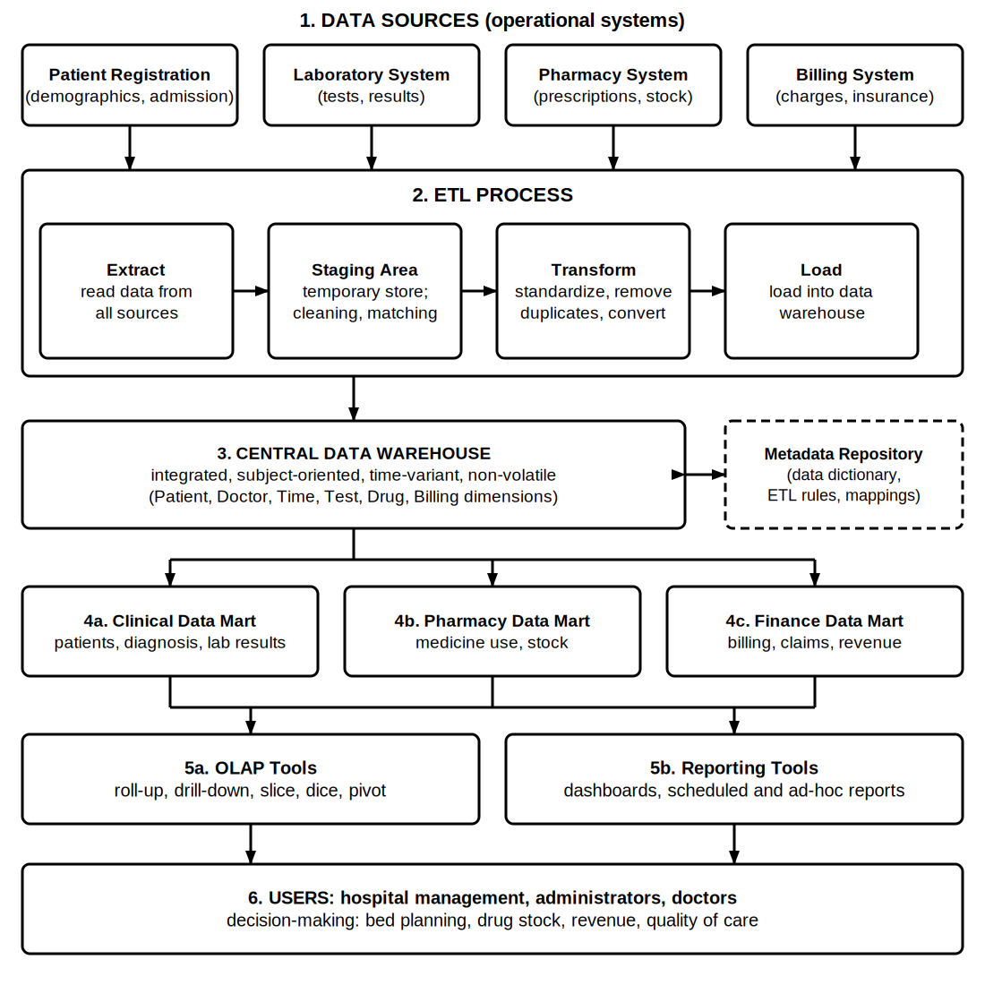
Figure 2: Data warehouse architecture for the hospital (data flows from top to bottom).
Function of each component
Component | Function in the hospital data warehouse
1. Data sources | Operational (OLTP) systems: Patient Registration (demographics, admission and discharge), Laboratory (tests and results), Pharmacy (prescriptions, stock), Billing (charges, payments, insurance claims). They run daily hospital work.
2. ETL process | Extract: reads data from all the sources. Transform: cleans, standardizes (patient ID, dates, drug and test codes), removes duplicates and integrates. Load: writes the clean data into the warehouse, on a schedule such as nightly.
Staging area | A temporary work area between the sources and the warehouse where data is held, checked, cleaned and matched, so the source systems and the warehouse are not disturbed.
3. Central data warehouse | Integrated, subject-oriented, time-variant and non-volatile repository holding detailed and summarized history of patients, treatments, tests, drugs and billing. It is the single source of truth.
Metadata repository | Data about data: data dictionary, source-to-target mappings, ETL rules, table definitions and business terms. It helps developers and users understand and manage the warehouse.
4. Data marts | Smaller subject-specific subsets of the warehouse: Clinical mart (diagnosis, lab results), Pharmacy mart (medicine use, stock) and Finance mart (billing, claims, revenue). Each gives its department faster, focused access.
5a. OLAP tools | Multidimensional analysis (roll-up, drill-down, slice, dice, pivot), for example patients by department, month and diagnosis.
5b. Reporting tools | Dashboards, scheduled reports and ad-hoc queries that present results as tables, charts and key performance indicators (KPIs).
6. Users | Hospital management, administrators and doctors, who use the results to make decisions.

How the architecture supports decision-making
- One integrated view: data from registration, laboratory, pharmacy and billing is combined, so management sees the complete picture of a patient and of the hospital.
- Reliable data: the ETL process and staging area clean the data, so decisions are based on accurate and consistent information.
- Historical analysis: the warehouse stores years of data, which allows trends and forecasts (for example seasonal rise of fever cases or bed demand).
- Fast analysis without affecting operations: queries run on the warehouse and data marts, not on the live hospital systems, so patient care software is not slowed.
- Self-service for each department: OLAP and reporting tools let users explore data and view dashboards.
- Examples of decisions: planning beds and staff, controlling drug stock and expiry, finding revenue leakage and claim rejections, comparing department performance, and improving quality of care.

